SpendWise: A Simple Backend Learning Project
Ideation Phase
Define the Problem Statements

Date | 08 March 2026
Team ID | SWTID-2026-2148
Project Name | SpendWise
Maximum Marks | 2 Marks

Customer Problem Statement Template:
A customer problem statement helps understand the user's perspective with a product. The SpendWise initiative focuses on meeting the needs of beginner backend development students learning technologies like Node.js, Express, MongoDB, and JWT. It highlights common challenges faced by beginners, such as confusion from complex project architectures and the difficulty of connecting theory to practice. Acknowledging these issues is essential to ensure the solution is simple, relevant, and easy to understand for learners.
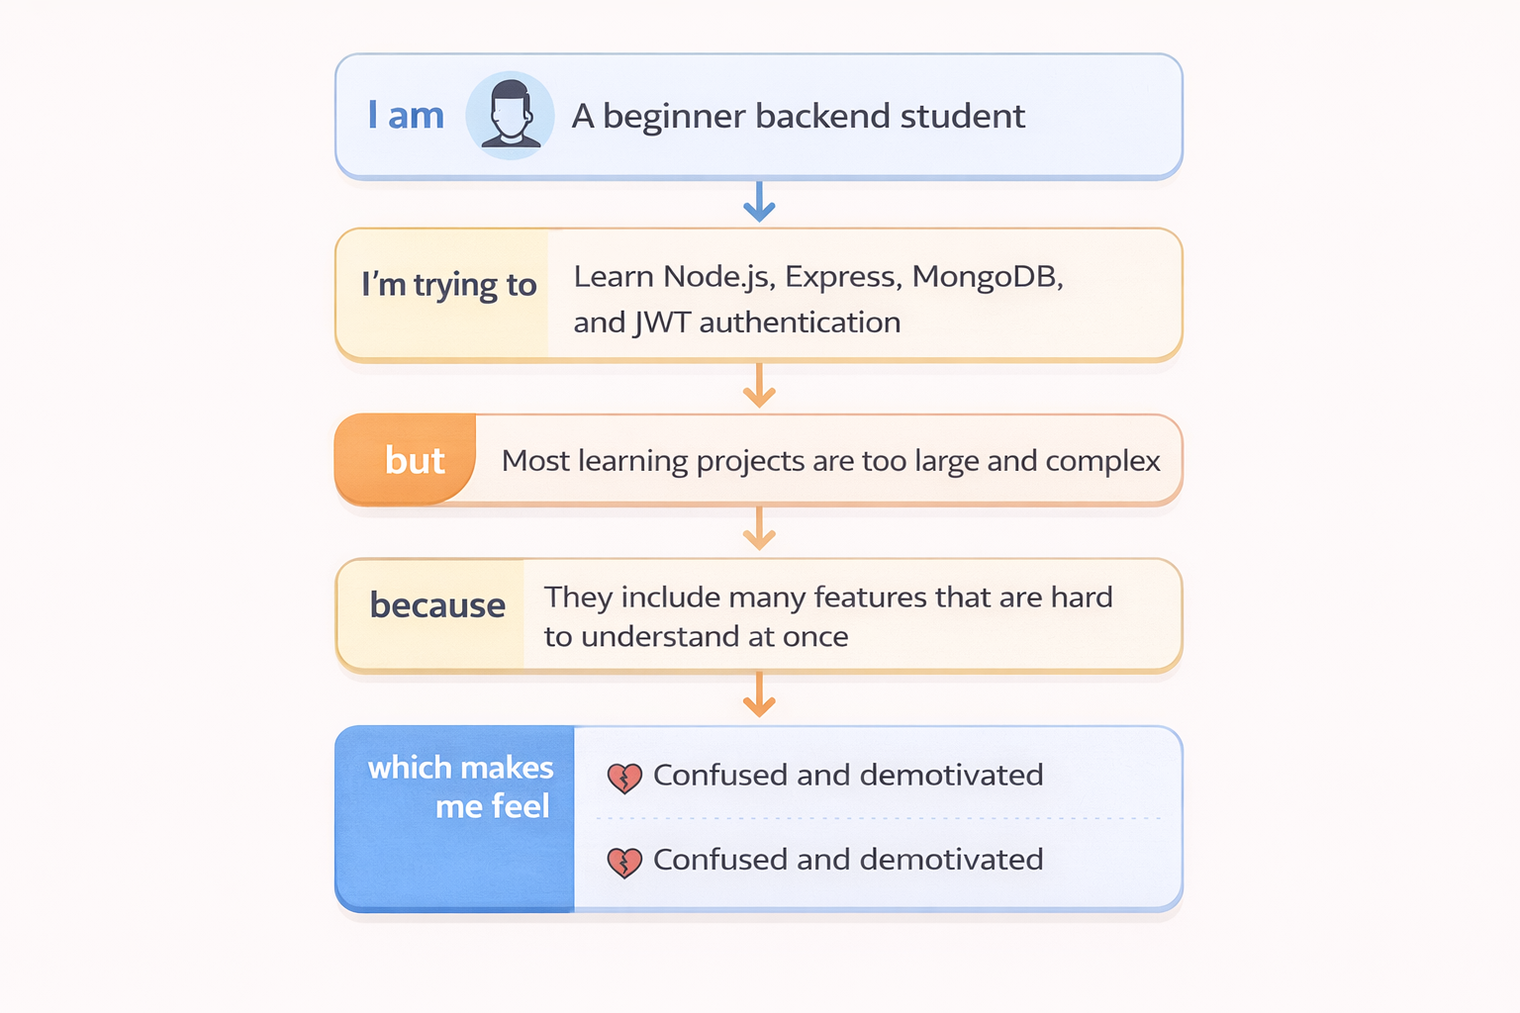

Example:
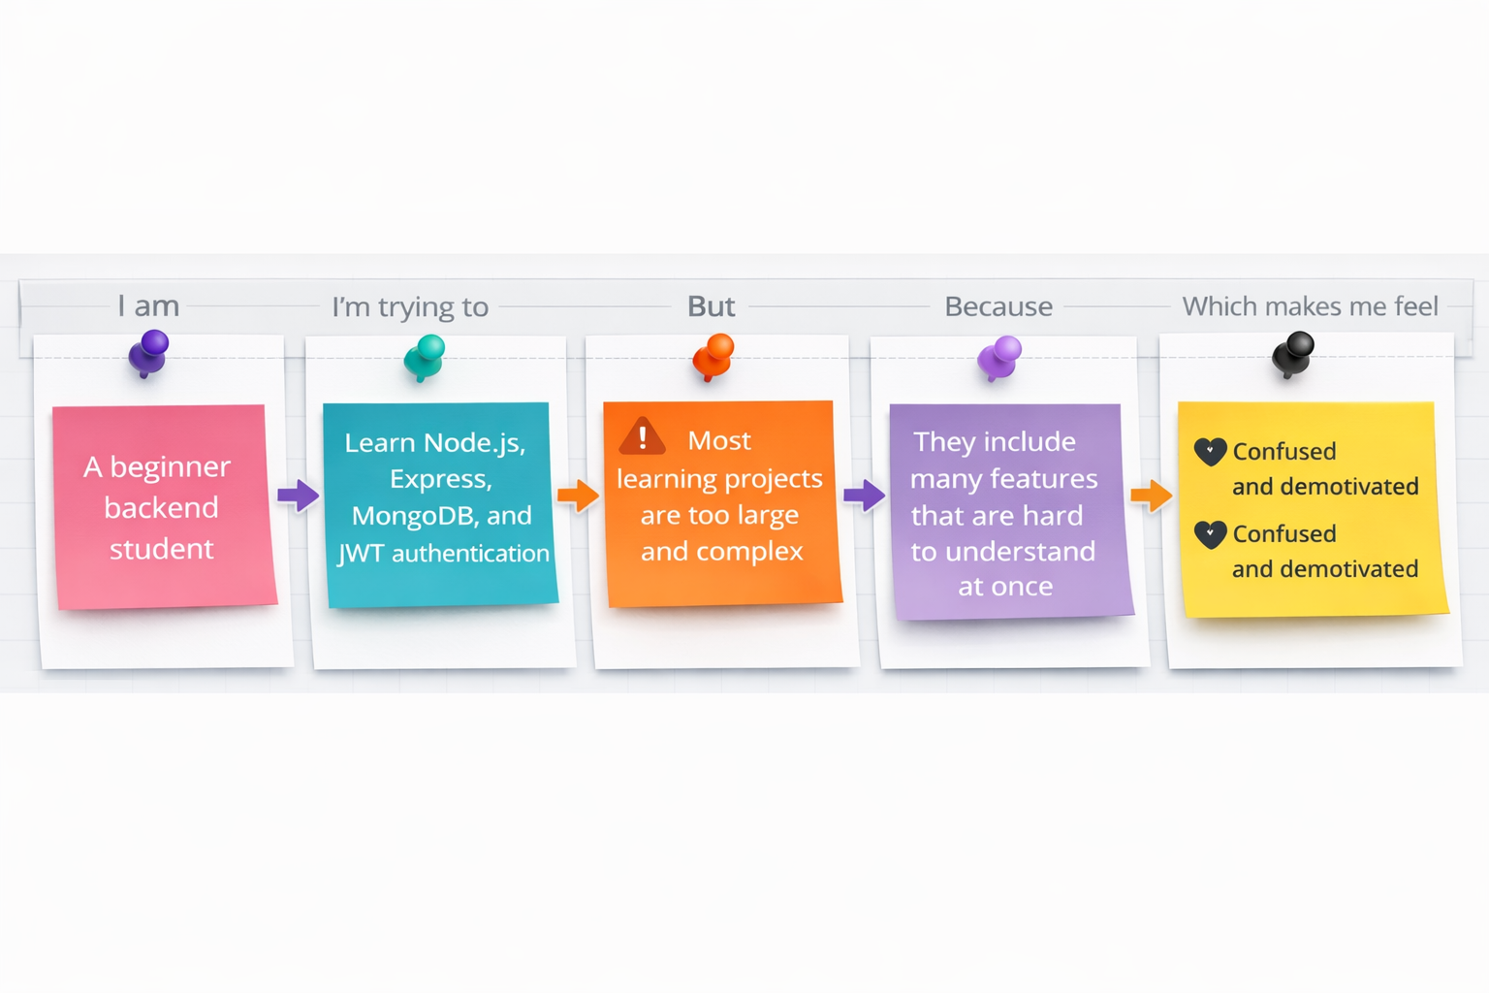
Problem Statement (PS) | I am (Customer) | I’m trying to | But | Because | Which makes me feel
PS-1 | A new developer on the SpendWise team | Understand the overall architecture and setup of the backend | The existing documentation is scattered and incomplete for new team members | I'm spending a lot of time digging through code and asking questions instead of contributing | Overwhelmed and slow to onboard
PS-2 | A backend developer tasked with adding a new feature to SpendWise | Implement a new endpoint that requires both user authentication (JWT) and database interaction (MongoDB) | The current code for JWT middleware and MongoDB queries is not consistently structured | I have to adapt my approach for each new endpoint, which slows down development and increases error potential | Inefficient and prone to mistakes
PS-3 | A quality assurance engineer testing the SpendWise API | Verify that all protected routes correctly enforce JWT authentication | There isn't a clear or automated way to test authentication failures across all endpoints | Manual testing is time-consuming and often misses edge cases or regressions when the authentication logic is updated | Concerned about security and the thoroughness of testing
PS-4 | A senior developer reviewing the SpendWise codebase | Ensure the application scales efficiently and maintains good performance under load | The current Express routing and MongoDB query patterns might not be optimized for high traffic | Most available projects are either too basic or too advanced | Proactive about future issues and responsible for scalability

